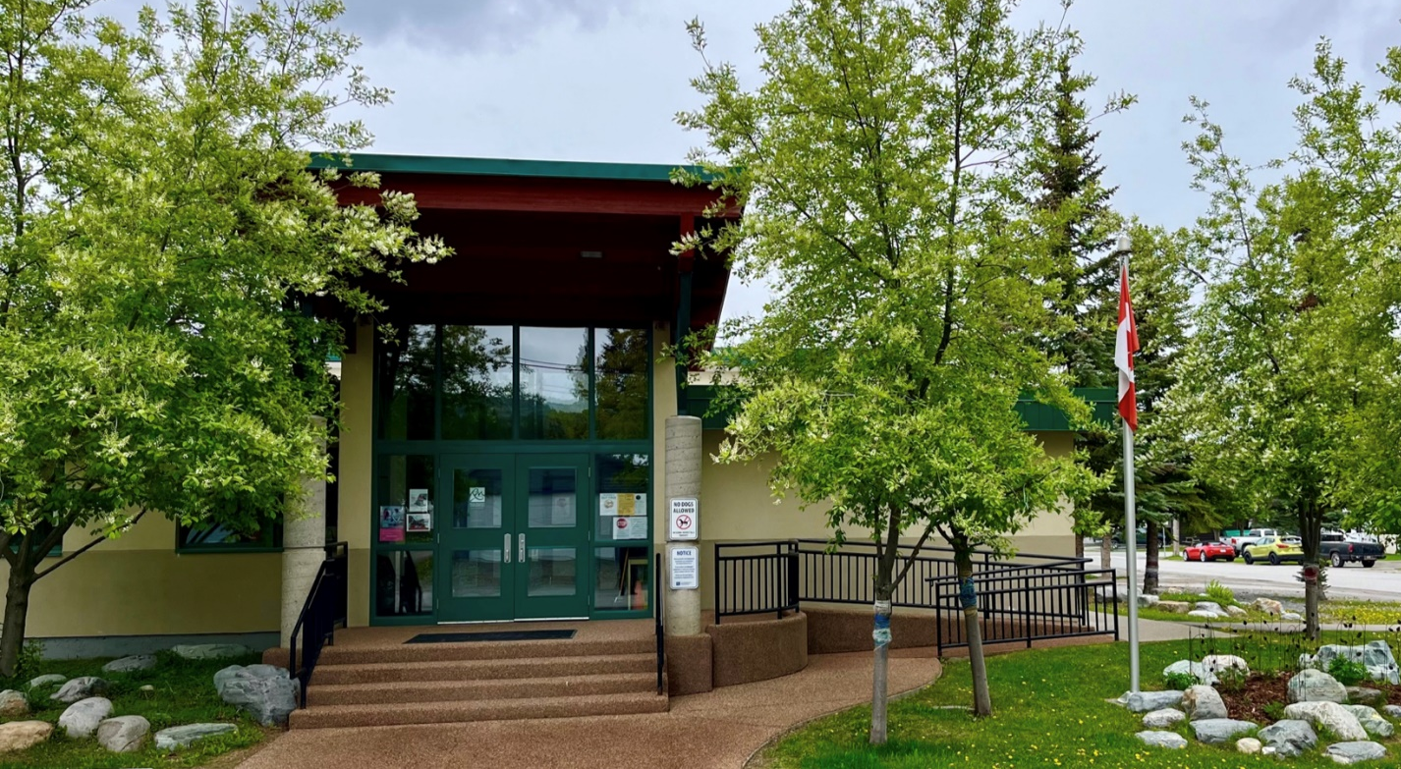
Dear Parents/Guardians,
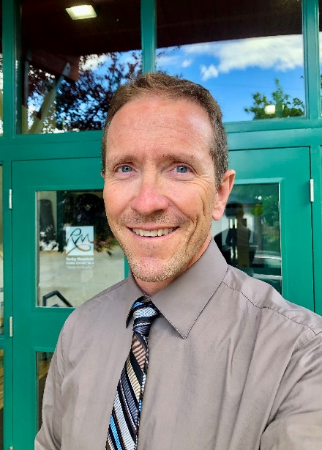
Greetings Lindsay Park Families! We hope you and your child(ren) have had a wonderful summer and are as excited as we are to embark upon a new school year. I, along with the entire staff, are looking forward to a wonderful school year and many great learning opportunities. We take great pride in our school and together we will all work hard to create a strong, compassionate, inclusive learning community. Our goal is to make learning engaging, experiential, and purposeful, and to provide every child the opportunity to succeed!
Please keep this Parent Handbook for reference throughout the school year as it contains useful information about how Lindsay Park Elementary School operates.
If at any time you have question or concerns, please do not hesitate to contact me at the school (250-427-2255).
Sincerely,
Dan Clark
Principal

Staffing 2024-2025

Dan Clark | Principal | Audrey Hunt | Admin Assistant
Shannon Magee | K | Astrid Maupu | Education Assistant
Crystal Sissons | K/1 | Jess Howard | Education Assistant
Laura Shore | K/1 | Chelsie Tierney | Education Assistant
Pam Taggart | Grade 1/2 | Jackie Seward | Education Assistant
Ana Pakenham | Grade 1/2 | Izabella Plante-Dresser | Education Assistant
Kim Weatherston | Grade 2/3 | Kristal Bodaly | Speech Language Pathologist
Erryn Turcon | Grade 2/3 | Matt Honeyman | Counselor
Meg Baker | Grade 2/3 | Michelle Wahlstrom | Indigenous Education Support Worker
Lindsay Rice | Library & Prep Coverage | Kim Balcom | Custodian
Sarah DeRuiter | Learning Services

School Times

Monday – Thursday |  | Friday
8:40 am | Warning Bell | 8:40 am | Warning Bell
8:45 am | Classes Begin | 8:45 am | Classes Begin
10:25-10:40 am | Recess | 10:25-10:40 am | Recess
12:00-12:40 pm | Lunch | 12:00 pm-12:35 pm | Lunch
2:48 pm | Dismissal | 1:15 pm | Dismissal

LINDSAY PARK ELEMENTARY SCHOOl vision, MISSION, and values

VISION STATEMENT
To create an open learning community that honors personal strengths and enables everyone to grow their thinking.

MISSION STATEMENT
We communicate positively and care for ourselves, each other, and this place, so that everyone feels they belong and can learn together.

VALUES
Wellbeing​
Our physical, mental and emotional health are necessary for success in all areas of our life.​
​Relationships​
Healthy relationships with open communication foster belonging, respect, trust and kindness.​
​Creativity​
Looking for possibilities, sharing ideas, expanding our thinking, and expressing ourselves in new ways.

AT LINDSAY PARK…
- Every child has the right to learn and feel valued.
- Children are treated with kindness, fairness, consistency, and love.
- Relationship and connection with children, families, community and the environment is paramount.
- We celebrate and value the diversity of all children.
- We acknowledge that we live and learn on the territory of the Ktunaxa First Peoples.
- We embed the First Peoples Principles of Learning.
- Ongoing family support and involvement are essential to each child’s success.
- We believe education is a life-long process for students and adults.
- We provide our children with leadership opportunities in and out of the classroom.
- We believe in a growth mindset.
- We are responsible actors and change-makers, who resolve challenges collaboratively and contribute to create a more sustainable world

SCHOOL POLICIES AND PROCEDURES

SUPERVISION
It is expected that all students will be outside, weather permitting, before school, at recess, and at lunch. Supervision starts before school at 8:20. Please do not drop your child off before this time as we cannot ensure their safety on the playground.
For those parents who are driving their children to school, it is very important that you drop them off in the parking lot by the gymnasium or along the fence before the bus lanes. Please, do NOT drop your child off in front of the building as it is incredibly dangerous for all pedestrians and vehicles. Our number one priority is student safety so please, help us by taking the extra couple of minutes to park safely.
Students are under adult supervision at recess and lunch and again, weather permitting, students are expected to be outside getting fresh air and free play. After school, students are supervised in the bus lanes while loading the bus. Please note that there is no supervision on the playground after school.

personal electronic devices
At Lindsay Park Elementary School, students can use school-provided electronic devices during appropriate times for learning. We have had several incidents with personal technology being used during class that have disrupted learning.
Personal devices like cell phones, cameras, and “smart” devices should stay at home. If students need to bring personal devices, they must keep them in their backpacks while at school. The only exception is for medically necessary devices.
Any personal devices found outside of backpacks will be kept safely in the office for families to pick up. The school is not responsible for any loss or damage to personal electronic devices.

WEATHER
Lindsay Park prides itself on being an environmental school that celebrates and embraces the outdoors. As such, students are outside for all recess times and need to be dressed appropriately. In the event of pouring rain, or severe temperatures, students will remain indoors in their classroom.

BICYCLE SAFETY
Bicycles must not be ridden on school grounds after arrival or before leaving at the end of the day. Helmets are required for all students as per City of Kimberley bylaw effective September 3, 1996. Students must follow basic bicycle safety and rules of the road.

ATTENDANCE
If your child is going to be late because of an appointment, please contact the school by phone. We encourage all students to be here by the start of the day so they can transition into their learning day.

ABSENCES
The school is responsible for keeping accurate attendance records which means that when a student is absent the administrative assistant is required to contact home unless you have informed the school. With multiple contact numbers/email addresses on file and students sometimes having more than one home, this can take a lot of time so please help us by calling when your child is going to be absent. Thank you.

ILLNESS OR INJURY
To prevent the spread of colds and flu and infectious diseases parents are asked to keep the child home until they are fully recovered. Parents will be contacted if a student becomes ill or receives an injury during the day. Student will remain at school until picked up.

STUDENTS ON MEDICATION
There are certain school district policies and practices that must be met before any teacher can administer or supervise the self-administration of medication. If your child requires medication throughout the school day, you MUST complete a form at the school prior to us being able to administer the medication. Please do not send your child to school with medication without following this procedure.

LEAVING THE SCHOOL GROUNDS
Students require a written and signed note or confirmation by phone from their parents if they wish to leave the school grounds during the school day.

STUDENTS GOING SOMEWHERE DIFFERENT AFTER SCHOOL
We MUST know either by a phone call or a note if a child is going somewhere else after school other than where he/she usually goes or is being picked up by someone. When the school is not informed of these changes it can cause much worry and confusion and can result in bus delays.

VALUABLES
Students are discouraged from bringing valuable games, toys or spending money to school. These items can be lost, damaged or stolen. Lindsay Park School cannot assume responsibility if valuables are brought to school.

DRESS CODE
Appropriate clothing is expected at all times. If clothing is immodest or if it has questionable decals or statements on it, the student will be asked to change or not wear the item again. Children need to have “inside footwear” as this is mandated by our fire regulations and they are expected to come to school with proper seasonal clothing so they can comfortably be outside before school, at recess and at lunch. If you require assistance in providing your child with winter clothing, please contact the school.

FOOD IN SCHOOL
We have students and staff with severe nut allergies in our school and, therefore, please do not bring any food with nuts to school. Students are not allowed to share or trade food due to allergies.

EATING AT LUNCHTIME
Goals:
- to have a healthy lunch so our bodies and brains can learn
- to do my best to help others have a good lunch
- to keep my eating space neat and tidy
How:
- be respectful of everyone and their lunch
- stand or sit at desk other than needing a garbage, putting things away, or using the washroom
- noise level needs to be acceptable
- take extra food home
- clean up when the bell rings - compost, garbage, recycling, desk top so we are ready to learn after lunch

FIELD TRIPS
School District No. 6 (Rocky Mountain) encourages the use of organized school field trips which meet worthwhile educational aims. Field trips serve to enrich the curriculum and provide worthwhile experiences not possible within the classroom. Prior to any student participating in a field trip activity, a parent permission form must be signed and returned to the school.

VOLUNTEERING
Any parents/guardians wishing to volunteer for any school activity MUST have a clear, current, criminal record check on file with the school and complete the Child Protection Protocol each school year. Criminal Record Checks are free for volunteers and can be picked up at the school or at the RCMP detachment. Younger siblings or pets are not permitted on school fieldtrips. If you have any questions about volunteering, please contact the school.

CODE OF CONDUCT

STATEMENT OF PURPOSE
At Lindsay Park School we believe that students are expected to conduct themselves appropriately while going to and from school and while attending any school function that occurs in any location. We believe:
- Appropriate student conduct is a necessity.
- Appropriate student conduct is the joint responsibility of students, parents and staff.
- Appropriate conduct should be modelled, taught and reinforced, recognized and acknowledged.
- Appropriate conduct is essential to enable students to function responsibly and effectively, and to this end all students are expected to know and abide by this Code of Conduct.
- Students should be helped to achieve success by protecting their rights to learn and play in a safe, inclusive environment in accordance with the BC Human Rights Code.
- Inappropriate conduct must be addressed.

LINDSAY PARK ELEMENTARY SCHOOL EXPECTATIONS
- Be Kind and Co-operative
- Be Safe
- Be Respectful
- Be Responsible

UNACCEPTABLE CONDUCT AND BEHAVIOURS
- Being unkind and uncooperative:
  - Any type of discrimination as outlined in the BC Human Rights Code
  - Hurtful or rude words
  - Physical violence
- Being unsafe:
  - Any behavior that can cause harm to self or others
- Being disrespectful:
  - Any behavior that negatively impacts and/or prevents the learning for self or others
- Being irresponsible:
  - Vandalism of personal property (self or others) or school property
  - Lying
  - Stealing
  - Not taking responsibility for one’s own actions

CONSEQUENCES OF UNACCEPTABLE CONDUCT AND BEHAVIOURS
Whenever possible or appropriate, consequences will be restorative in nature. We recognize that children make mistakes and the focus will be on learning from the mistake, which will allow the child to grow and enhance their ability to make better choices and follow the code of conduct rather than simply punishing the student. In these instances, the child will be asked to explain their choices, make amends, and talk about appropriate choices to make if the same situation occurs.
If unacceptable conduct continues after the above approach has been taken, disciplinary action will follow these guidelines:
- Student will be referred to Student Services Team
- Behavioural intervention/individual behavior/safety plan will be created
- Parent involvement
- Administration involvement which may include:
  - Director of Learning Services involvement
  - School Board involvement
  - Suspension

We recognize that students with special needs may be unable to comply with the Code of Conduct due to an intellectual, physical, sensory, emotional or behavioral challenge. In these situations, we will ensure:
- Appropriate supports and interventions are in place
- Planning involves strategies and/or actions to prevent further incidents

discrimination
We also guarantee that no student, parent, or employee will be discriminated on the grounds of any of the following:
- race,
- colour,
- ancestry,
- place of origin,
- religion,
- marital status,
- family status,
- physical or mental disability,
- sex,
- sexual orientation,
- gender identity or expression; and
- age

